TABLA 1. Paraclínicos de la paciente
 | 28/05/15 | 31/05/15 | 02/06/15 |  | 03/06/15
HEMOGRAMA  LEUCOCITOS (10⁹/L)  NEUTROFILOS (%)  LINFOCITOS (%)  BASÓFILOS (%)  EOSINÓFILOS (%)  MONOCITOS (%)  HEMOGLOBINA (G/DL)  HEMATOCRITO (%)  VCM (FL)  PLAQUETAS (10⁹/L) | 4980  60.8  35.5  0.2  1.3  2.2  13  38.6  97  224
NITROGENO UREICO (MG/DL) | 17.8
CREATININA (MG/DL) | 0.82 | 0.69
PROTEINAS TOTALES (G/DL) | 6.1
ALBUMINA (G/DL) | 4.4
BILLIRRUBINA TOTAL (MG/DL)  B. DIRECTA  B. INDIRECTA | 0.27  0.13  0.14 | 0.35  0.16  0.19 | 0.34  0.13  0.21
TGO (U/L) |  | 26
TGP (U/L) | 65 | 45
GLUCOSA (MG/DL) | 66
FOSFATASA ALCALINA | 133
CALCIO (MG/DL) | 11.03
MAGNESIO (MG/DL) | 1.94
PROTEINA C REACTIVA (MG/L) | 0.7 | 20.2
DEPURACION CREATININA 24H (ML/MIN) |  | 381
PROTEINURIA 24 HORAS (MG/24H) |  | 829.01
FERRITINA (NG/ML) |  |  | 385.5
FROTIS SANGRE PERIFERICA |  |  | NORMAL
RETICULOCITOS (%) |  |  | 5.2
HIERRO SERICO (MCG/DL) |  |  |  | 76.6
TRANSFERRINA (MG/DL) |  |  |  | 182.4
ANTICUERPOS ANTINUCLEARES |  |  |  | NO REACTIVO
COMPLEMENTO C3 (MG/DL) |  |  |  | 100.9
COMPLEMNTO C4 (MG/DL) |  |  |  | 26.3
TSH (MLU/L) | 1.5
ELISA VIH | NO REACTIVO

FIGURA 1. Radiografía de tórax.
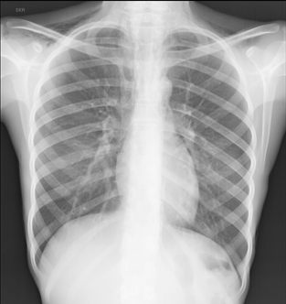
FIGURA 2. Radiografía de tórax lateral.
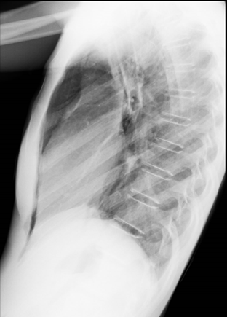
FIGURA 3. TCAR torax. Se evidencia presencia de enfisema en cuello y neumomediastino.
